﻿
﻿
UNITED STATES
SECURITIES AND EXCHANGE COMMISSION
Washington, D.C. 20549
SCHEDULE 14A
Proxy Statement Pursuant to Section 14(a) of
the Securities Exchange Act of 1934
(Amendment No. )
Filed by the Registrant ☒
Filed by a Party other than the Registrant ☐
Check the appropriate box:
☐ | Preliminary Proxy Statement
☐ | Confidential, for Use of the Commission Only (as permitted by Rule 14a-6(e)(2))
☐ | Definitive Proxy Statement
☒ | Definitive Additional Materials
☐ | Soliciting Material Pursuant to §240.14a-12
Koss Corporation
(Name of Registrant as Specified In Its Charter)
﻿
(Name of Person(s) Filing Proxy Statement, if other than the Registrant)
Payment of Filing Fee (Check the appropriate box):
☒ | No fee required.
☐ | Fee paid previously with preliminary materials.
☐ | Fee Computed on table in exhibit required by Item 25(b) per Exchange Act Rule 14a-66(i)(1) and 0-11
﻿
﻿

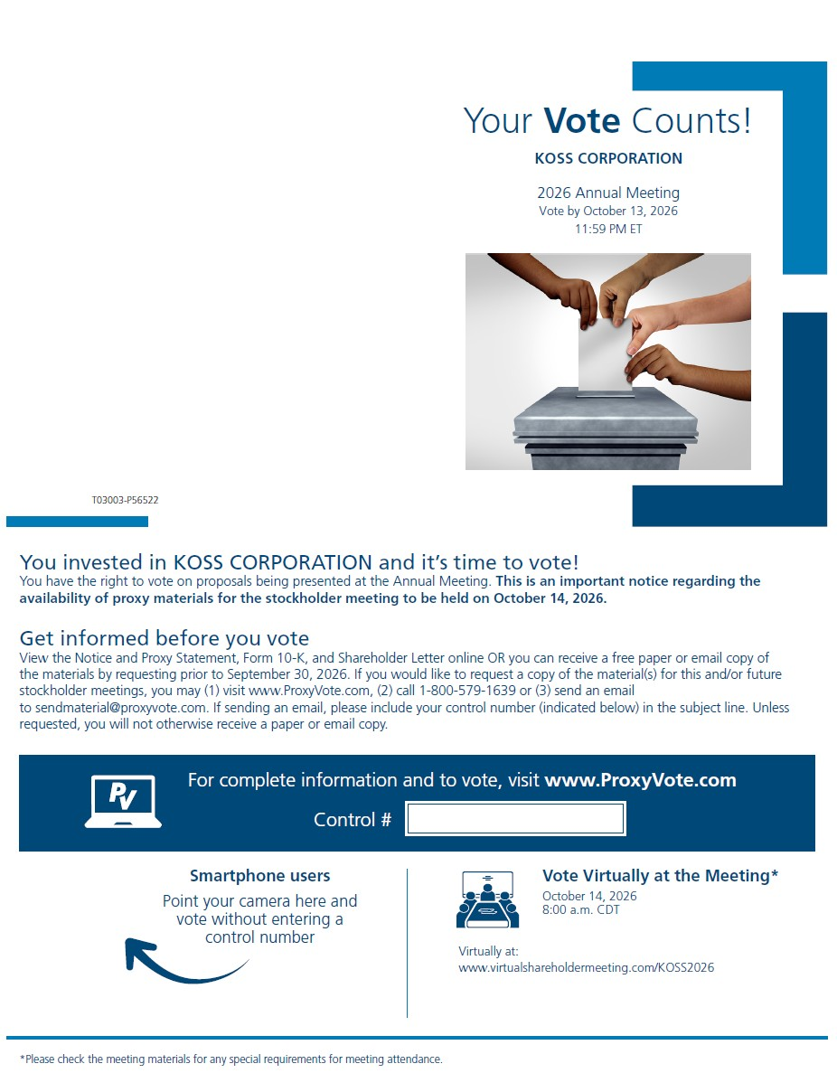

Your Vote Counts! KOSS CORPORATION 2023 Annual Meeting Vote by October 17, 2023 11:59 PM ET V22144-P97924 You invested in KOSS CORPORATION and it’s time to vote! You have the right to vote on proposals being presented at the Annual Meeting. This is an import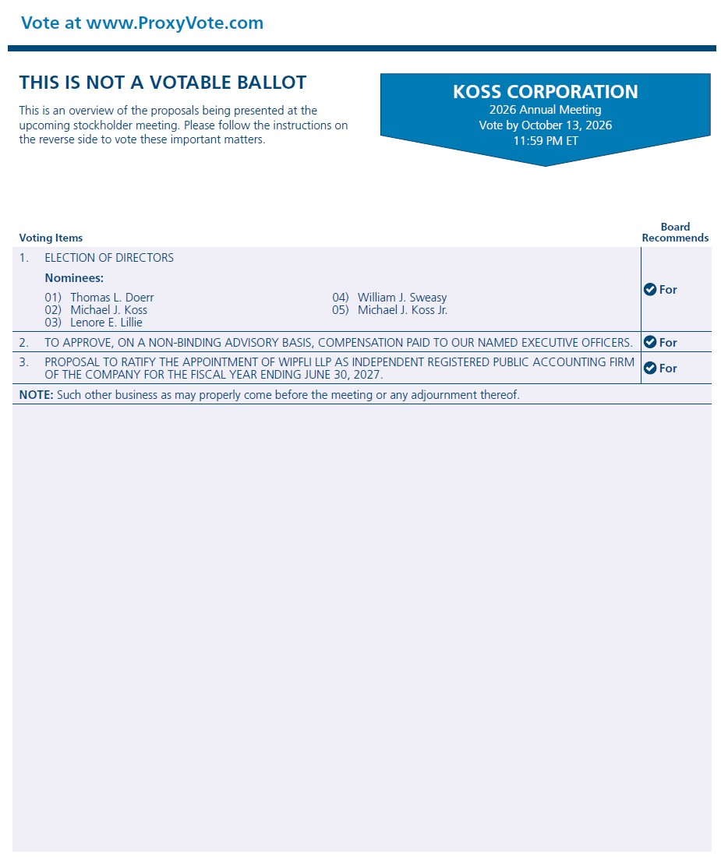t notice regarding the availability of proxy material for the shareholder meeting to be held on October 18, 2023. Get informed before you vote View the Notice and Proxy Statement, Form 10-K and Shareholder Letter online OR you can receive a free paper or email copy of the material(s) by requesting prior to October 4, 2023. If you would like to request a copy of the

