UNITED STATES
SECURITIES AND EXCHANGE COMMISSION
Washington, D.C. 20549

SCHEDULE 14A INFORMATION

Proxy Statement Pursuant to Section 14(a) of
the Securities Exchange Act of 1934

Filed by the Registrant ☒

Filed by a Party other than the Registrant ☐

Check the appropriate box:
☐ | Preliminary Proxy Statement
☐ | Confidential, for Use of the Commission Only (as permitted by Rule 14a-6(e)(2))
☒ | Definitive Proxy Statement
☐ | Definitive Additional Materials
☐ | Soliciting Material Pursuant to §240.14a-12

Koss Corporation
(Name of Registrant as Specified In Its Charter)

Not Applicable
(Name of Person(s) Filing Proxy Statement, if other than the Registrant)
Payment of Filing Fee (Check the appropriate box):
☒ |  | No fee required.
☐ |  | Fee paid previously with preliminary materials.
☐ |  | Fee computed on table in exhibit required by Item 25(b) per Exchange Act of 1934 Rules 14a-16(i)(1) and 0-11.
1

KOSS CORPORATION
4129 NORTH PORT WASHINGTON AVENUE
Milwaukee, Wisconsin 53212

NOTICE OF ANNUAL MEETING OF STOCKHOLDERS

to be held on

October 14, 2026

The Annual Meeting of Stockholders of Koss Corporation (“Koss” or the “Company”) will be held on Wednesday, October 14, 2026, at 8:00 a.m. Central Time. The Annual Meeting will be solely by means of remote communication. You can attend the Annual Meeting by visiting www.virtualshareholdermeeting.com/KOSS2026, where you will be able to listen to the meeting live, submit questions and vote online. You are cordially invited to attend.
The Annual Meeting is being held for the following purposes:

1.to elect five (5) directors from among the nominees described in the Proxy Statement accompanying this notice;
2.to approve, on a non-binding advisory basis, compensation paid to our Named Executive Officers;
3.to ratify the appointment of WIPFLI, LLP as the independent registered public accounting firm of the Company for the fiscal year ending June 30, 2027; and
4.to transact such other business as may properly be brought before the annual meeting.

Only stockholders of record at the close of business on August 24, 2026, will be entitled to notice of, and to vote their shares at, the Annual Meeting. Information regarding the matters to be considered and voted upon at the Annual Meeting is set forth in the Proxy Statement accompanying this notice.

In order to assist us in preparing for the Annual Meeting, we urge you to promptly sign and date the enclosed proxy and return it in the enclosed envelope, which requires no postage.

The Notice of Internet Availability of Proxy Materials and the enclosed proxy statement are being made available to our stockholders on or about August 28, 2026.

By Order of the Board of Directors
/s/ Kim M. Schulte
Kim M. Schulte, Secretary
Milwaukee, Wisconsin
August 28, 2026

‎
2

KOSS CORPORATION

PROXY STATEMENT

2026 ANNUAL MEETING OF STOCKHOLDERS

October 14, 2026
_______________

INTRODUCTION

THIS PROXY STATEMENT IS FURNISHED IN CONNECTION WITH THE SOLICITATION OF PROXIES BY THE BOARD OF DIRECTORS OF KOSS CORPORATION (“Koss” or the “Company”) for use at the Company’s 2026 Annual Meeting of Stockholders (together with any adjournment or postponement thereof, the “Meeting” or “Annual Meeting”) for the purposes set forth in the foregoing Notice of Annual Meeting of Stockholders.

Date, Time and Location. The Meeting will be held on Wednesday, October 14, 2026, at 8:00 a.m. Central Time. The Annual Meeting will be a virtual meeting held solely by means of remote communication. You can attend the Annual Meeting by visiting www.virtualshareholdermeeting.com/KOSS2026, where you will be able to listen to the meeting live, submit questions and vote online. You are cordially invited to attend.

Purposes of the Meeting. At the Meeting, stockholders will consider and vote upon the following: (i) to elect five (5) directors for one-year terms; (ii) to approve, on a non-binding advisory basis, executive compensation paid to our Named Executive Officers; (iii) to ratify the appointment of WIPFLI, LLP (“WIPFLI”) as the independent registered public accounting firm for the fiscal year ending June 30, 2027; and (iv) to transact such other business as may properly be brought before the Meeting.

Proxy Solicitation. The Board of Directors is soliciting the stockholders’ proxies, the cost of which will be borne by the Company. Proxies will be solicited primarily by mail and may be made by directors, officers and employees personally or by telephone. The Company will reimburse brokerage firms, custodians and nominees for their out-of-pocket expenses incurred in forwarding proxy materials to beneficial owners. Proxy statements, annual reports, and proxies will be mailed to stockholders on or around September 4, 2026.

Quorum and Voting Information. Only stockholders of record of the Company’s common stock (the “Common Stock”) at the close of business on August 24, 2026 (the “Record Date”) are entitled to vote at the Meeting. As of the Record Date, there were issued and outstanding 9,466,438 shares of Common Stock, each of which is entitled to one vote per share. A quorum of stockholders is necessary to take action at the Meeting. A majority of the shares of Common Stock entitled to vote, represented in person or by proxy, will constitute a quorum of stockholders at the Meeting. Votes cast by proxy or in person at the Meeting will be tabulated by the inspector of elections appointed for the Meeting. The inspector of elections will determine whether or not a quorum is present at the Meeting. Abstentions (or, with respect to the election of directors, “withhold” votes) will be treated as shares of Common Stock that are present and entitled to vote at the meeting and are therefore counted to determine a quorum. If a broker indicates on the proxy that it does not have discretionary authority to vote certain shares of Common Stock on a particular matter (a “broker non-vote”), those shares will not be considered as present and entitled to vote with respect to that matter (although those shares are considered entitled to vote for quorum purposes and may be entitled to vote on other matters).

The five nominees receiving the greatest number of votes cast in person or by proxy at the Meeting will be elected directors of the Company. The vote required to approve, by non-binding advisory basis, the compensation paid to our Named Executive Officers, to recommend to ratify the appointment of WIPFLI as the independent registered public accounting firm of the Company for the fiscal year ending June 30, 2027, and to approve any other matter to be presented at the Meeting, is the affirmative vote of a majority of the shares of Common Stock present in person or represented by proxy at the Meeting and entitled to vote on the subject matter (unless, with respect to any other such matter, the vote of a greater number or voting by classes is required by law or the Company’s certificate of incorporation). Abstentions will have no effect on the election of directors and will have the same effect as votes “against” approval, by non-binding advisory basis, on the compensation paid to our Named Executive Officers, and the ratification of WIPFLI as the Company's independent registered public accounting firm for the fiscal year ending June 30, 2027.

‎
3

A broker holding shares in “street name” for a beneficial owner has discretion (but is not required) to vote the client’s shares with respect to “routine” matters if the client does not provide voting instructions. The broker, however, is not permitted to vote the client’s shares with respect to “non-routine” matters without voting instructions. A “broker non-vote” occurs when your broker submits a proxy for your shares but does not vote on a particular proposal because the broker does not have discretionary voting power for that item and has not received instructions from you. Broker non-votes, if any, will be counted for purposes of determining a quorum. Broker non-votes will not be treated as votes cast on the election of directors and will not be treated as votes entitled to be cast thereon with respect to approval, by non-binding advisory basis, on the compensation paid to our Named Executive Officers, each of which is a “non-routine” matter, and, therefore, will have no effect on the vote required for approval of such proposals. The ratification of the appointment of WIPFLI as the Company’s independent registered public accounting firm for the fiscal year ending June 30, 2027, is considered a “routine” matter. Therefore, even if your broker does not receive voting instructions from you, your broker is entitled (but not required) to vote your shares on this proposal.
Stockholders do not have cumulative voting rights and appraisal rights are not applicable to the matters being voted upon.

Proxies and Revocation of Proxies. A proxy in the accompanying form that is properly executed, duly returned to the Company and not revoked will be voted in accordance with the instructions contained therein. In the event that any matter not described in this Proxy Statement properly comes before the Meeting, the accompanying form of proxy authorizes the persons appointed as proxies thereby (the “Proxyholders”) to vote on such matter in their discretion. At the present time, the Company knows of no other matters that are to come before the Meeting. See “TRANSACTION OF OTHER BUSINESS.” If no instructions are given with respect to any particular matter to be acted upon, a proxy will be voted “FOR” the election of all nominees for director named in this Proxy Statement, “FOR” approval of the advisory resolution on the compensation paid to our Named Executive Officers, and “FOR” the ratification of WIPFLI as the Company’s independent registered public accounting firm for the fiscal year ending June 30, 2027. If other matters properly come before the Annual Meeting, the persons appointed to vote the proxies will vote on these matters in accordance with their best judgment.

Each such proxy granted may be revoked at any time before it is voted by filing with the Secretary of the Company a written notice of revocation, by delivering to the Company a duly executed proxy bearing a later date, or by attending the Meeting and voting online.

Annual Report and Other Information. The Company’s Annual Report to Stockholders, which includes the Company’s audited financial statements for the fiscal year ended June 30, 2026, although not a part of this Proxy Statement, is delivered herewith. We also make available on our website, www.koss.com, our annual reports on Form 10-K, quarterly reports on Form 10-Q, current reports on Form 8-K, and amendments to those reports filed or furnished pursuant to Section 15(d) of the Exchange Act as soon as reasonably practicable after we electronically file such material with, or furnish it to, the SEC. Stockholders may also obtain a copy of these reports, without charge, upon request to: Secretary, c/o Koss Corporation, 4129 North Port Washington Avenue, Milwaukee, Wisconsin 53212.
Submission of Future Stockholder Proposals and Nominations. Under certain conditions, stockholders may request that we include a proposal or director nomination at a forthcoming meeting of our stockholders in the proxy materials of the Company for such meeting. Under Exchange Act Rule 14a-8, any stockholder desiring to present a proposal to take action at the 2027 annual meeting of stockholders and include such proposal in our proxy materials must ensure that we receive the proposal, to be eligible for inclusion in our proxy statement, at our principal executive offices at 4129 North Port Washington Avenue, Milwaukee, Wisconsin 53212 no later than May 7, 2027. To avoid controversy over when a stockholder proposal is received, stockholder proposals should be sent by certified mail, return receipt requested, and should be addressed to the Secretary of the Company. The Nominating Committee will consider qualified director candidates recommended by stockholders if such recommendations for director are submitted in writing to the Secretary, c/o Koss Corporation, 4129 North Port Washington Avenue, Milwaukee, Wisconsin 53212 and include the following information: (i) name and address of the stockholder making the recommendation, (ii) name and address of the candidate, and (iii) pertinent biographical information about the candidate.
To comply with the universal proxy rules, stockholders who intend to solicit proxies in support of director nominees other than Company nominees must provide notice that sets forth the information required by Rule 14a-19 under the Exchange Act no later than August 15, 2027.

Important Notice Regarding the Availability of Proxy Materials for the
Stockholder Meeting to Be Held on October 14, 2026

The Notice of Annual Meeting of Stockholders, Proxy Statement and Proxy Card
are available at www.koss.com.

‎
4

PROPOSAL 1. ELECTION OF DIRECTORS

The By-Laws of the Company provide that the number of directors on the Board of Directors of the Company (the “Board”) will be no fewer than four and no greater than twelve. We had five directors during fiscal year 2026 and will elect five directors for fiscal year 2027. Each director elected will serve until the next Annual Meeting of Stockholders and until the director’s successor is duly elected, or until his or her prior death, resignation, or removal. The five nominees that receive the most votes will be elected to serve on our Board for the next year.

Information as to the Nominees

The following identifies the nominees for the five director positions and provides information as to their business experience for the past five years. Each nominee is presently a director of the Company:

Thomas L. Doerr, 82, has been a director of the Company since 1987 and was elected Lead Director in 2015. In 1972, Mr. Doerr co-founded Leeson Electric Corporation and served as its President and Chief Executive Officer until 1982. The company manufactures industrial electric motors. In 1983, Mr. Doerr incorporated Doerr Corporation as a holding company for the purpose of acquiring established companies involved in distributing products to industrial and commercial markets. Mr. Doerr brings a wealth of entrepreneurial experience to the Board including a hands-on understanding of strategy development, operations, and finance. Mr. Doerr has been directly involved in all aspects of his businesses including operations, distribution, purchasing, finance, and quality control.

Michael J. Koss, 72, has held various positions at the Company since 1976 and has been a director of the Company since 1985. He was elected President and Chief Operating Officer of the Company in 1987, Chief Executive Officer in 1991, Vice-Chairman in 1998 and Chairman in 2015. Mr. Koss brings to the Board intimate knowledge of the Company’s daily operations as the Company’s Chief Executive Officer. In addition, Mr. Koss’s extensive senior leadership experience in various positions gives him a broad understanding of the types of operational, financial, and strategic issues that affect the Company. He has been a driving force behind the Company’s new product development.

William J. Sweasy, 73, has been a director of the Company since 2015. Mr. Sweasy is Chairman of Red Wing Shoe Co., which is a multi-facility manufacturer and retailer of purpose-built footwear, setting the standard of excellence for work boots. Mr. Sweasy adds valuable experience to the Board in the areas of executive leadership, large international company experience and a diverse background in strategy development, operational management, financial oversight, and consumer goods experience.
Lenore E. Lillie, 67, has been a director of the Company since 2022. Until her retirement from Koss Corporation in 2021, Ms. Lillie held a variety of positions at the Company since 1985, and most recently, Vice President, Operations. Ms. Lillie brings to the board a broad experience in supply chain management, Asian contract manufacturing, domestic manufacturing, cost control, inventory management, pricing strategies, product development, product life cycles, shipping, and quality. Ms. Lillie adds valuable familiarity with the daily operations of the Company, including personnel issues, strategic planning, supply chain challenges, and cost challenges.

Michael J. Koss, Jr., 42, has been a director of the Company since 2025. Mr. Koss held a variety of positions at the Company since 2010, and is currently serving as Executive Vice President. Prior to working at the Company, Mr. Koss received a Master’s Degree in Business Administration (MBA) from Marquette University in 2009. Mr. Koss served on the Board of Directors of Milwaukee Film from 2016 – 2024. Mr. Koss brings to the Board a broad experience in marketing, product development, sales, finance, customer experience and strategy and is leading the Company’s newly announced corporate development strategy.
‎
5

Experience, Qualifications, Attributes and Skills

The Company believes that each director nominee possesses the following experience, qualifications, attributes and skills, in addition to those reflected above, as these are required of all candidates nominated for election or reelection to the Board:
•The highest level of personal and professional ethics, integrity and values;
•An inquiring and independent mind;
•Practical wisdom and mature judgment;
•Broad training and experience at the policy-making level in business, finance and accounting, or technology;
•Expertise that is useful to Koss and complementary to the background and experience of other Board members, so that an optimal balance and diversity of Board members can be achieved and maintained;
•Willingness to devote the required time to carrying out the duties and responsibilities of Board membership;
•For new nominees, a commitment to serve on the Board for several years to develop knowledge about Koss’s business;
•Willingness to represent the best interests of all stockholders and objectively appraise management performance; and
•Involvement only in activities or interests that do not conflict with the director’s responsibilities to Koss and its stockholders.
The Company expects that the “Koss Family” (Michael J. Koss, John Koss, Jr., and Michael J. Koss, Jr. and their affiliates), along with the members of the Board of Directors, who account for in the aggregate 4,192,103 shares of Common Stock outstanding as of the Record Date, will vote “for” the election of all nominees named above to the Board of Directors.

THE BOARD OF DIRECTORS RECOMMENDS THAT
STOCKHOLDERS VOTE “FOR” THE ELECTION OF ALL NOMINEES
NAMED ABOVE TO THE BOARD OF DIRECTORS.
‎
6

Board Leadership Structure

The current Chairman of our Board and Chief Executive Officer is Mr. Michael J. Koss. The Company has no fixed policy with respect to the separation of the offices of the Chairman of the Board and Chief Executive Officer. Our bylaws permit these positions to be held by the same person, and the Board believes that it is in the best interests of the Company to retain flexibility in determining whether to separate or combine the roles of Chairman and Chief Executive Officer based on our circumstances. The Board has determined that it is appropriate for Mr. Koss to serve as both Chairman and Chief Executive Officer because combining the roles of Chairman and Chief Executive Officer: (1) enhances the alignment between the Board and management in strategic planning and execution as well as operational matters, (2) avoids the confusion over roles, responsibilities and authority that can result from separating the positions, and (3) streamlines board process in order to conserve time for the consideration of the important matters the Board needs to address. Further, all four of our current non-executive Board members have been deemed to be independent by our Board; therefore, we believe our Board structure provides sufficient independent oversight of our management. The Board has designated Mr. Doerr as lead independent director.

Board Committees

The Board has appointed the following standing committees for auditing and accounting matters, executive compensation, and Board nominations. Each member of these committees is an “independent director” as defined in Nasdaq Listing Rule 5605(a)(2).

Audit Committee. The Audit Committee, which was composed of Mr. Sweasy (Audit Committee Chairman), Mr. Doerr, and Ms. Lillie during the fiscal year ended June 30, 2026, reviews and evaluates the effectiveness of the Company’s financial and accounting functions, including reviewing the scope and results of the audit work performed by the independent registered public accounting firm and by the Company’s internal accounting staff. The Board has determined that Mr. Sweasy is an “Audit Committee Financial Expert” as that term is defined in Item 407(d)(5)(ii) of Regulation S-K promulgated by the Securities and Exchange Commission (the “SEC”). The Audit Committee met four times during the fiscal year ended June 30, 2026 and all current members were in attendance. The independent registered public accounting firm was present at all of these meetings to discuss their audit scope, the results of their audit and quarterly reviews. For more information about the Audit Committee meetings, see the “Audit Committee Report.” The Audit Committee is governed by a written charter, which is available on the Company's website.

Compensation Committee. The Compensation Committee, which was composed of Mr. Doerr (Compensation Committee Chairman), Mr. Sweasy and Ms. Lillie, during the fiscal year ended June 30, 2026, has responsibility for reviewing and recommending compensation for all employees whose annual salaries exceed $150,000. The Chief Executive Officer assists the Compensation Committee with the review of compensation, which is determined based on a qualitative and quantitative review of the performance of the employee and the performance of the Company, as well as peer company data. The Compensation Committee does not use any outside consultants to make compensation decisions and retains ultimate decision-making authority for all executive pay matters. The Compensation Committee met two times during the fiscal year ended June 30, 2026. The Koss Corporation 2023 Equity Incentive Plan (the “Plan”), which was approved by the Board as well as the stockholders at the Company’s 2023 Annual Meeting, is administered by the Compensation Committee. Subject to the express provisions of the Plan, the Committee has complete authority to (i) designate individuals to whom benefits are granted and when; (ii) prescribe the terms and conditions of benefits granted; (iii) construe and interpret the Plan; (iv) promulgate, amend and rescind rules and regulations relating to the administration of the Plan; (v) accelerate, purchase, adjust or remove restrictions from benefits; and (vi) exercise discretion to make any and all other determinations which it deems to be necessary or advisable for the administration of the Plan. The Compensation Committee is governed by a written charter, which is available on the Company's website.

Nominating Committee and Director Nomination Process. The Nominating Committee, which was composed of Mr. Doerr (Nominating Committee Chairman), Mr. Sweasy and Ms. Lillie, during the fiscal year ended June 30, 2026, has responsibility for overseeing the director nomination process and for identifying and evaluating potential candidates and recommending candidates to the Board for nomination. The Nominating Committee met one time during fiscal year 2026. When the Board considers additional or replacement members, all candidates are evaluated by the Nominating Committee on the basis of outstanding achievement in their professional careers, broad experience, wisdom, personal and professional integrity and their experience with and understanding of the business environment. With respect to minimum qualifications of candidates, the Nominating Committee will consider candidates who have the experiences, skills, and characteristics necessary to gain a basic understanding of the principal operational and financial objectives and plans of the Company, the results of operations and financial condition of the Company, and the relative standing of the Company and its business segments in relation to its competitors. Any nominees in support of which stockholders intend to solicit proxy must be submitted by the deadline described in the Introduction section of this Proxy Statement. The Nominating Committee does not currently have a written charter. The Board nominations are presented to and approved by the full Board.

The Nominating Committee does not have a formal diversity policy with respect to the Board, but it reviews the background and qualifications of each nominee to determine such nominee’s experience, competence, and character and assesses such nominee’s potential contribution to the Board of Directors, taking into account the then-existing composition of the Board of Directors and such other factors as the Nominating Committee deems appropriate. With respect to diversity, certain of our directors have strong technical backgrounds that are
7

relevant to our industry; other directors have a background in management. We believe that the backgrounds and skills of our directors bring a diverse range of experience, opinions, and perspectives to the Board.

Risk Oversight

While management is responsible for assessing and managing the risks to the Company, our Board takes an active role, as a whole and also at the committee level, in overseeing the material risks facing the Company, including operational, financial, legal and regulatory, strategic and reputational risks. Risks are considered in virtually every business decision and as part of the Company’s overall business strategy. Our Board committees also regularly engage in risk assessment as a part of their regular function. The Audit Committee discusses with management and our independent registered accounting firm the Company’s major financial risk exposures and compliance with legal and regulatory requirements, and the steps management has taken to monitor and control such exposures. The Compensation Committee is responsible for overseeing the management of risks relating to the Company’s executive compensation plans and arrangements. The Nominating Committee manages risks associated with corporate governance, including risks associated with the independence of the Board and reviews risks associated with potential conflicts of interest affecting directors and executive officers of the Company. While each committee is responsible for evaluating certain risks and overseeing the management of such risks, our entire Board is regularly informed through committee reports about such risks. The Board regularly engages in discussion of financial, operational, legal, cybersecurity and information technology, economic, and other risks. Because overseeing risk is an ongoing process that is inherent in the Company’s strategic decisions, our Board discusses risk throughout the year at other meetings in relation to specific proposed actions. Additionally, our Board exercises its risk oversight function in approving the annual budget and in reviewing the Company’s long-range strategic and financial plans with management.

Attendance at Board and Committee Meetings

During the fiscal year ended June 30, 2026, the Board held four meetings. Each director attended 100% of the aggregate of (i) all meetings of the Board, plus (ii) all meetings of the committees on which he or she served during the periods that he or she served.

Attendance at Annual Meetings

The Company's policy is that, absent extraordinary circumstances, each member of the Board shall attend each annual stockholder meeting. Mr. Michael J. Koss, Mr. Doerr, Mr. Sweasy, Mr. Michael J. Koss, Jr. and Ms. Lillie attended last year’s virtual annual meeting held on October 15, 2025.

Independence of the Board

Each of Mr. Doerr, Ms. Lillie and Mr. Sweasy, is “independent” as such term is defined in Nasdaq Listing Rule 5605(a)(2). These independent directors constitute a majority of the Board, as required under Nasdaq Listing Rule 5605(b)(1).

Communications with the Board

Stockholders may communicate with the Board, individually or as a group, by sending written communications to: Koss Corporation, 4129 North Port Washington Avenue, Milwaukee, Wisconsin 53212. Stockholders may also communicate with members of the Board by telephone (414) 964-5000 or facsimile (414) 964-8615. If any correspondence is addressed to the Board or to a member of the Board, that correspondence is forwarded directly to the Board or a member of the Board.

Code of Ethics

The Code of Ethics for the Company’s directors, officers and employees was filed as Exhibit 14 to the Company’s Annual Report on Form 10-K for the fiscal year ended June 30, 2026, and is available on the Company’s website. In the event that the Company amends any of the provisions of, or grants a waiver under, the Code of Ethics that requires disclosure under the applicable law or SEC rules, it intends to disclose such amendment or waiver on its website.
‎
8

Insider Trading Policy
The Company is committed to promoting high standards of ethical business conduct and compliance with applicable laws, rules and regulations. As part of this commitment, the Company has adopted the Insider Trading and Tipping Policy governing the purchase, sale, and/or other dispositions of the Company’s securities by its directors, officers, and employees that are reasonably designed to promote compliance with insider trading laws, rules and regulations, and the exchange listing standards applicable to us. A copy of the Company’s Insider Trading and Tipping Policy is filed as Exhibit 19.1 to the Company’s Annual Report on Form 10-K.
Hedging Transactions
Under our Insider Trading and Tipping Policy, we prohibit our officers and directors and other participants in our equity incentive plans from engaging in hedging transactions, monetization transactions or similar arrangements involving Company securities, such as zero-cost collars and forward sale contracts.
Executive Officers

Information is provided below with respect to the executive officers of the Company. Each executive officer is appointed annually by the Board of Directors and serves for one year or until his or her successor is appointed.

 |  |  |  |  |  | Current Position
Name |  | Age |  | Positions Held |  | Held Since
Michael J. Koss (1) |  | 72 |  | President, Chief Executive Officer |  | 1987  ‎(Chief Executive Officer since 1991)
Kim M. Schulte |  | 60 |  | Chief Financial Officer |  | 2021
John C. Koss, Jr. (1) |  | 69 |  | Vice President — Sales |  | 1988 (2)
Michael J. Koss, Jr. (1) |  | 42 |  | Vice President — Marketing and Product |  | 2016
(1)Michael J. Koss is a brother of John Koss Jr. and father to Michael J. Koss Jr.
(2)On May 6, 2025, John Koss, Jr., notified the Company of his plans to retire after June 30, 2026

Beneficial Ownership of Company Securities

The following table sets forth, as of August 24, 2026, the number of shares of Common Stock beneficially owned (as defined under applicable regulations of the SEC) and the percentage of such shares to the total number of shares outstanding, for all director nominees, for each executive officer named in the Summary Compensation Table (see “Summary Compensation Table”), for all directors and executive officers as a group and for each person and each group of persons who, to the knowledge of the Company as of August 24, 2026, were the beneficial owners of more than 5% of the outstanding shares of Common Stock.

 |  | Number of |  | Percent of
 |  | Shares |  | Outstanding
 |  | Beneficially |  | Common
Name and Business Address (1) |  | Owned (2) |  | Stock (3)
Thomas L. Doerr |  | — |  | *
Michael J. Koss (4) |  | 3,846,410 |  | 40.63%
Lenore E. Lillie |  | 2,500 |  | *
William J. Sweasy |  | 30,000 |  | *
John C. Koss, Jr. (5) |  | 270,176 |  | 2.86%
Michael J. Koss, Jr. (6) |  | 26,012 |  | *
Kim M. Schulte |  | — |  | *
All directors and executive officers as a group (7 persons) (7) |  | 4,175,098 |  | 44.06%
Restated Koss Voting Trust (8) |  | 2,696,634 |  | 28.46%
(*) Denotes beneficial ownership of less than 1%.
(1)Unless otherwise noted, the business address of all persons named in the above table is c/o Koss Corporation, 4129 North Port Washington Avenue, Milwaukee, WI 53212.
(2)Unless otherwise noted, amounts indicated reflect shares as to which the beneficial owner possesses sole voting and dispositive powers. Also included are shares subject to stock options if such options are exercisable within 60 days of August 24, 2026.
9

(3)All percentages shown in the above table are based on 9,466,438 shares outstanding and entitled to vote on August 24, 2026, plus (for Michael J. Koss, John C. Koss, Jr., Michael J. Koss, Jr., and for all directors and executive officers as a group) the respective number of options exercisable within 60 days of August 24, 2026. The percentage calculation assumes, for each individual owning options and for directors and executive officers as a group, the exercise of that number of stock options that are exercisable within 60 days of August 24, 2026.
(4)Includes the following shares which are deemed to be “beneficially owned” by Michael J. Koss: (i) 3,471,541 shares owned directly or by reason of family relationships, including 2,696,634 shares held directly in Mr. Koss’ capacity as voting trustee of a voting trust (the “Voting Trust”) established pursuant to the Restatement of the Koss Voting Trust Agreement, dated March 23, 2022 (the “Voting Trust Agreement”); (ii) 157,801 shares by reason of the allocation of those shares to his account under the Koss Corporation Employee Stock Ownership Plan (“KESOT”) and his ability to vote such shares; and (iii) 217,068 shares held by the Koss Foundation, of which he is an officer. Mr. Koss has no options exercisable within 60 days of August 24, 2026.
(5)Includes the following shares which are deemed to be “beneficially owned” by John C. Koss, Jr.: (i) 196,028 shares owned directly or by reason of family relationships and (ii) 74,148 shares by reason of the allocation of those shares to his account under the KESOT and his ability to vote such shares. Mr. Koss has no options exercisable within 60 days of August 24, 2026.
(6)Includes the following shares which are deemed to be “beneficially owned” by Michael J. Koss, Jr.: (i) 26,000 shares owned directly or by reason of family relationships and (ii) 12 shares by reason of the allocation of those shares to his account under the KESOT and his ability to vote such shares. Mr. Koss has no options exercisable within 60 days of August 24, 2026.
(7)Includes the shares which are deemed to be beneficially owned by Thomas L. Doerr, Michael J. Koss, Lenore E. Lillie, William J. Sweasy, John C. Koss Jr., Michael J. Koss, Jr. and Kim M. Schulte
(8)The sole voting trustee of the Restated Koss Voting Trust is Michael J. Koss. The term of the Koss Family Trust is indefinite. Under the Voting Trust Agreement, the trustee holds full voting and shared dispositive power over the shares held by the Voting Trust. All of the 2,696,634 shares held by the Voting Trust are included in the number of shares shown as beneficially owned by Michael J. Koss (see Note (4) above).
SUMMARY COMPENSATION TABLE

The following table presents certain summary information concerning compensation paid or accrued by the Company for services rendered in all capacities during the fiscal years ended June 30, 2026 and 2025, for (i) the Chairman of the Board and Chief Executive Officer (“CEO”) of the Company, and (ii) our two most highly compensated executive officers other than the individual who served as our Principal Executive Officer during fiscal 2026 (collectively, including the CEO, the “Named Executive Officers”).

 |  |  |  |  |  |  |  | Non-Equity
 |  |  |  |  |  | Option |  | Incentive Plan |  | All Other
 |  |  |  | Salary |  | Awards |  | Compensation |  | Compensation
Name & Principal Position |  | Year |  | ($) |  | ($) (1) |  | ($) (2) |  | ($) |  |  | Total ($)
Michael J. Koss |  | 2026 |  | 325,000 |  | — |  | — |  | 57,620 | (3) |  | 382,620
Chairman of the Board and CEO |  | 2025 |  | 325,000 |  | — |  | — |  | 54,509 | (3) |  | 379,509
Michael J. Koss, Jr |  | 2026 |  | 221,250 |  | 276,724 |  | 5,016 |  | 28,143 | (4) |  | 531,133
Vice President — Marketing & Product |  | 2025 |  | 200,000 |  | — |  | 596 |  | 26,256 | (4) |  | 226,852
Kim M. Schulte |  | 2026 |  | 235,417 |  | 150,897 |  | 39,000 |  | 17,742 | (5) |  | 443,056
Chief Financial Officer |  | 2025 |  | 229,000 |  | — |  | 30,000 |  | 16,520 | (5) |  | 275,520
(1)Represents the aggregate grant date fair value of stock option awards calculated in accordance with FASB ASC Topic 718. See Note 13 to the Company’s consolidated financial statements for the year ended June 30, 2026, included in the Annual Report on Form 10-K for 2026 for the relevant assumptions used to determine the valuation of option awards.
(2)Michael J. Koss, Jr. received performance awards based on the Company’s quarterly pre-tax earnings throughout the year. Kim M. Schulte received non-equity compensation based on the accomplishment of specific goals that are not dependent upon measurable financial metrics.
(3)Michael J. Koss received $7,937 in fiscal 2026 and $7,688 in fiscal 2025 in Company matching contributions under the Company’s 401(k) Plan. Car related expenses were paid by the Company for Michael J. Koss in the amount of $1,684 in fiscal 2026 and $1,531 in fiscal 2025, and premiums were paid by the Company for life insurance in the amount of $24,769 in fiscal 2026 and $23,132 in fiscal 2025. Premiums
10

for supplemental medical care reimbursement were paid by the Company in the amount of $14,628 for fiscal 2026 and $13,602 in fiscal 2025. Premiums paid by the Company for disability insurance were $8,146 in each of fiscal 2026 and 2025.
(4)Michael J. Koss, Jr. received $6,262 in fiscal 2026 and $5,899 in fiscal 2025 in Company matching contributions under the Company’s 401(k) Plan. Premiums for life insurance were paid by the Company in the amount of $346 in fiscal 2026 and $301 in fiscal 2025. Premiums for supplemental medical care reimbursement were paid by the Company in the amount of $21,126 in fiscal 2026 and $19,650 in fiscal 2025.
(5)Kim M. Schulte received $8,326 in fiscal 2026 and $7,688 in fiscal 2025 in Company matching contributions under the Company’s 401(k) Plan. Premiums were paid by the Company for life insurance in the amount of $1,573 in fiscal 2026 and $1,517 in fiscal 2025. Premiums for supplemental medical care reimbursement were paid by the Company in the amount of $7,428 in fiscal 2026 and $6,906 in fiscal 2025.
The Company has not entered into any employment agreements, severance agreements or change in control arrangements with any of its executive officers.
‎
11

Other Benefit Plans
The Company has certain benefit plans and arrangements which are available to the Named Executive Officers including the following:

•Supplemental Medical Care Reimbursement Plan. Each officer of the Company is covered by a medical care insurance plan for medical expenses incurred that are not covered under the group health insurance.
•Employee Stock Ownership Plan. In December 1975, the Company adopted the KESOT, which is a form of employee benefit plan designed to invest primarily in employer securities. The KESOT is qualified under Section 401(a) of the Internal Revenue Code and Michael J. Koss and Kim M. Schulte currently serve as members of the KESOT Committee. All full-time employees with at least six months of uninterrupted service with the Company are eligible to participate in the KESOT. Contributions to the KESOT are allocated to the accounts of participants in proportion to the ratio that a participant’s compensation bears to total compensation of all participants and are immediately vested. Accounts are adjusted each year to reflect the investment experience of the trust. Voting rights for all shares are passed through to the participant for whose account such shares are allocated and must be voted by the Trustees in accordance with the participants’ direction. The KESOT was amended and restated effective July 1, 2023, with no material changes except for those required by applicable laws. As of June 30, 2026, the KESOT held 301,132 shares of Common Stock (3.18% of the total number of shares outstanding).
•Stock Option Plans. As of July 25, 2022, the 2012 Koss Corporation Omnibus Incentive Plan (the “Prior Plan”) expired. The Koss Corporation 2023 Equity Incentive Plan (the “2023 Plan”) was approved by the shareholders at the 2023 Annual Meeting of Stockholders and superseded and replaced the Prior Plan. Concurrently with the adoption of the 2023 Plan, the Board terminated the Prior Plan. Any awards outstanding under the Prior Plan on the date of stockholder approval of the 2023 Plan remain subject to and will be paid under the Prior Plan, and any shares subject to outstanding awards under the Prior Plan that subsequently expire, terminate, or are canceled or forfeited for any reason without issuance of shares automatically become available for issuance under the 2023 Plan.
The purposes of the 2023 Plan are to enhance our ability to attract and retain highly-competent employees, consultants, and directors, and to motivate those service providers to serve the Company and to expend maximum effort to improve our business results and earnings, by providing to those service providers an opportunity to acquire or increase a direct proprietary interest in our operations and future success of the Company.
The Compensation Committee of the Board of Directors administers the 2023 Plan and provides for the granting of various stock-based incentive awards to eligible participants, primarily officers and certain key employees of the Company. 2,000,000 shares of common stock were authorized for issuance under the 2023 Plan, plus any shares subject to awards remaining outstanding under the Prior Plan that expire or are otherwise forfeited, canceled, or terminated. The Company’s Board of Directors will determine the terms and conditions under which an option will become exercisable but expects that stock options granted under the 2023 Plan will vest over a three-to-five-year period from the date of grant. An option will expire no more than ten years from its grant date, with the exception of incentive stock options held by a 10% stockholder, which will expire no more than five years from the grant date. As with the Prior Plan, pursuant to the 2023 Plan, new shares will be issued upon exercise of stock options. As of June 30, 2026, 200,000 stock-based awards have been granted under the 2023 Plan.
•Supplemental Executive Retirement Plan. The Board of Directors has by resolution entered into a Supplemental Executive Retirement Plan with Michael J. Koss which calls for Michael J. Koss to receive annual cash compensation following his retirement from the Company (“Retirement Payments”) in an amount equal to 2% of the base salary of Michael J. Koss, multiplied by his number of years of service to the Company (for example, if Michael J. Koss worked 25 years, then he would be entitled to receive 50% of his base salary). The base salary shall be calculated using the average base salary of Michael J. Koss during the three years preceding his retirement. The Retirement Payments are to be paid to Michael J. Koss monthly until his death, and after his death shall continue to be paid monthly to his surviving spouse until her death. The Company has a deferred compensation liability of $2,462,285 and $2,226,454 recorded as of June 30, 2026 and 2025, respectively, for this arrangement.
•Profit Sharing Plan. Every quarter of each fiscal year, the Company sets aside a percentage of any operating profits and distributes it to all employees (except Michael J. Koss, John C. Koss, Jr., and Kim M. Schulte) based on their hourly rate of pay. All Koss employees (except Michael J. Koss, John C. Koss, Jr., and Kim M. Schulte) are eligible for profit sharing if they have been employed for the complete fiscal quarter.
•401(k) Plan. All employees of the Company are eligible to participate in the Company’s 401(k) Plan at the beginning of the fiscal quarter after they have completed one full fiscal quarter of service. Employees are able to defer a dollar amount up to the federal yearly maximum. In 2026, the Company matched the employee dollar deferral with a $0.25 per dollar match. In 2027, the Company has no plans to change the match of the employee dollar deferral. Such matches are completely at the discretion of the Company. The funds that are deferred and matched are immediately 100% vested to the employee’s 401(k) account. The
12

employees may allocate their funds among twenty-two investment options, or they may self-direct their funds to a qualified 401(k) of their choice.
OUTSTANDING EQUITY AWARDS AT FISCAL YEAR END

The following table sets forth information on outstanding option awards issued under the Prior Plan and held by the Named Executive Officers as of June 30, 2026, including the number of shares underlying both exercisable and un-exercisable portions of each stock option as well as the exercise price and the expiration date of each outstanding option. The Prior Plan expired on July 25, 2022 and, as such, there were no equity awards granted under the Prior Plan since then. As further discussed below, concurrent with the termination of the Prior Plan, the 2023 Plan was approved at the 2023 Annual Meeting of the Stockholders. During the year ended June 30, 2026, 200,000 option awards were granted under this 2023 Plan.

 |  | Number |  | Number
 |  | of Securities |  | of Securities
 |  | Underlying |  | Underlying
 |  | Unexercised |  | Unexercised |  | Option
 |  | Options |  | Options |  | Exercise |  |  | Option
 |  | (#) |  | (#) |  | Price |  |  | Expiration
Name |  | Exercisable |  | Unexercisable |  | ($) |  |  | Date
Michael J. Koss |  | — |  | — |  | $ | — |  | —
Michael J. Koss, Jr. |  | — |  | 100,000 |  |  | 4.73 |  | 5/6/2031
Kim M. Schulte |  | — |  | 50,000 |  |  | 4.30 |  | 5/6/2036
All options for Michael J. Koss, Jr. vest in equal annual installments over a period of four (4) years with the first 25% vesting one year after the date of grant. The options are exercisable for five (5) years and expire on the date five years from the date of grant. All options for Kim M. Schulte vest in equal annual installments over a period of four (5) years with the first 20% vesting one year after the date of grant. The options are exercisable for ten (10) years and expire on the date ten years from the date of grant.
STOCK OPTION GRANT TIMING
The Compensation Committee determines the timing of equity awards based on the Company's annual compensation review process, the commencement of employment, promotions, retention considerations, or other business factors. The Company does not have a formal policy with respect to the timing of stock option grants, however, stock options are not granted in anticipation of the release of material nonpublic information and the release of material non-public information is not timed based upon option grant dates or for the purpose of affecting the value of executive compensation. In addition, the Company does not take material non-public information into account when determining the timing and terms of stock option grants. Historically, when stock options were granted, it has been the practice of the Company to approve equity grants at its annual Compensation Committee meeting.
During the fiscal year ended June 30, 2026, the Company granted 150,000 stock option awards to certain Named Executive Officers during the period beginning four business days before and ending one business day after the filing of the Company’s Quarterly Report on Form 10-Q that disclosed material nonpublic information for the quarter ended March 31, 2026. These grants were made pursuant to the Company's regular equity compensation program and were approved at the Compensation Committee meeting in May 2026 in accordance with the terms of the Company's equity incentive plan.
‎
13

The following table provides the information required by Item 402(x)(2) of Regulation S-K with respect to option awards granted to Named Executive Officers during the applicable period.
Name |  | Grant date |  | Number of securities underlying option award (#) |  |  | Exercise price of the award |  |  | Grant date fair value of the award |  | Percentage change in the closing market price of the securities underlying the award between the trading day ending immediately prior to the disclosure of material nonpublic information and the trading day beginning immediately following the disclosure of material nonpublic information
Michael J. Koss |  | N/A |  | — |  |  | — |  |  | — |  | —
Michael J. Koss, Jr. |  | May 6, 2026 |  | 100,000 |  | $ | 4.73 |  | $ | 276,724 |  | (17.5)%
Kim M. Schulte |  | May 6, 2026 |  | 50,000 |  | $ | 4.30 |  | $ | 150,897 |  | (9.3)%
The Company did not consider the timing of the filing of the Form 10-Q or the anticipated disclosure of material nonpublic information in determining the grant date for these awards.
‎
14

PAY VERSUS PERFORMANCE
The following table presents information on the compensation paid to our principal executive officer (“PEO”) as set forth in the Summary Compensation Table (“SCT”), the adjusted values of compensation actually paid to our PEO, average compensation paid to our non-PEO named executive officers (“NEOs”) other than the PEO as set forth in the SCT, and the adjusted values of average compensation actually paid to our NEOs other than the PEO, each as calculated in accordance with the SEC rules, as well as certain Company performance measures for the three fiscal years ended June 30, 2026. The years reported below refer to fiscal years.
Year |  | Summary Compensation Table Total for PEO ($) (1) |  | Compensation Actually Paid to PEO ($) (2) |  | Average Summary Compensation Table Total for Non-PEO Named Executive Officers ($) (3) |  | Average Compensation Actually Paid to Non-PEO Named Executive Officers ($) (4) |  | Value of Initial Fixed $100 Investment Based on Total Shareholder Return ($) (5) |  | Net Income (Loss) ($) (6)
2026 |  | 382,620 |  | 382,620 |  | 487,095 |  | 463,450 |  | 108.4 |  | (391,464)
2025 |  | 379,509 |  | 572,037 |  | 278,614 |  | 398,944 |  | 137.8 |  | (874,831)
2024 |  | 383,817 |  | 424,797 |  | 288,134 |  | 320,072 |  | 120.3 |  | (950,911)
(1)Michael J. Koss (our Chairman of the Board and CEO) was the PEO for all years shown. The amounts reflect the total compensation reported for our PEO in the “Total” column of the Summary Compensation Table for each corresponding year.
(2)The amounts reported represent the compensation actually paid to the PEO, computed in accordance with Item 402(v) of Regulation S-K. In accordance with Item 402(v) of Regulation S-K, below are the adjustments made to the amount reported for our PEO in column (1) above for each year to arrive at compensation actually paid to our PEO during each year shown.
Year |  | Summary Compensation Table Total for PEO ($) (a) |  | Reported Summary Compensation Table Value of PEO Equity Awards ($) (b) |  | Adjusted Value of Equity Awards ($) (c) |  | Compensation Actually Paid to PEO ($)
2026 |  | 382,620 |  | — |  | — |  | 382,620
(a)This column represents the amount of total compensation reported for Mr. Koss in 2026 in the “Total” column of the Summary Compensation Table.
(b)No Option Awards or Stock Awards were granted to the PEO in fiscal year 2026.
(c)This column represents the adjustment to equity awards granted in prior years to arrive at “compensation actually paid” to Mr. Koss for 2026 (“Subject Year”). The adjusted amount is determined by adding (or subtracting, as applicable) the following: (i) the year-end fair value of any equity awards granted in the Subject Year that are outstanding and unvested as of the end of the Subject Year; (ii) the amount of change as of the end of the Subject Year (from the end of the prior fiscal year) in the fair value of any awards granted in prior years that are outstanding and unvested as of the end of the Subject Year; (iii) for awards that are granted and vest in the Subject Year, the fair value as of the vesting date; (iv) for awards granted in prior years that vest in the Subject Year, the amount equal to the change as of the vesting date (from the end of the prior fiscal year) in the fair value; (v) for awards granted in prior years that are determined to fail to meet the applicable vesting conditions during the Subject Year, a deduction for the amount equal to the fair value at the end of the prior fiscal year; and (vi) the dollar value of any dividends or other earnings paid on stock or option awards in the Subject Year prior to the vesting date that are not otherwise reflected in the fair value of such award or included in any other component of total compensation for the Subject Year. The valuation assumptions used to calculate fair values did not materially differ from those disclosed at the time of grant. The amounts added or subtracted to determine the adjusted amount are as follows:
‎
15

Year |  | Year End Fair Value of Equity Awards Granted in the Year ($) |  | Year over Year Change in Fair Value of Outstanding and Unvested Equity Awards at Fiscal Year End Granted in Prior Years ($) |  | Fair Value as of Vesting Date of Equity Awards Granted and Vested in the Year ($) |  | Change in Fair Value of Equity Awards Granted in Prior Years that Vested in the Year ($) |  | Fair Value at the End of the Prior Year of Equity Awards that Failed to Meet Vesting Conditions in the Year ($) |  | Value of Dividends or Other Earnings Paid on Stock or Option Awards not Otherwise Reflected in Fair Value or Total Compensation in the Summary Compensation Table for the Year ($) |  | Adjusted Value of Equity Awards ($)
2026 |  | — |  | — |  | — |  | — |  | — |  | — |  | —
(3)These amounts reflect the average total compensation reported for the Company’s named executive officers as a group (excluding our PEO) in the “Total” column of the Summary Compensation Table for each corresponding year. The non-PEO named executive officers are comprised of Michael Koss, Jr. and Kim M. Schulte for 2026, John C. Koss, Jr. and Kim M. Schulte for 2025 and 2024.
(4)The amounts reported represent the average “Compensation Actually Paid” to the non-PEO NEOs as a group, computed in accordance with Item 402(v) of Regulation S-K. In accordance with Item 402(v) of Regulation S-K, below are the adjustments made to the amount reported for such NEOs in column (1) above for each year to arrive at compensation actually earned by or paid to the non-PEO NEOs during each year shown.
Year |  | Average Summary Compensation Table Total for Non-PEO NEOs ($) (a) |  | Average Reported Summary Compensation Table Value of Non-PEO NEOs Equity Awards ($) (b) |  | Average Non-PEO NEO Adjusted Value of Equity Awards ($) (c) |  | Average Compensation Actually Paid to Non-PEO Named Executive Officers ($)
2026 |  | 487,095 |  | (213,810) |  | 190,165 |  | 463,450
(a)This column represents the average of the amounts reported for the Company’s NEOs as a group (excluding Mr. Koss) in the “Total” column of the Summary Compensation Table in 2026.
(b)During fiscal year 2026, 100,000 options were awarded to Michael J. Koss, Jr. and 50,000 options were awarded to Kim M, Schulte.
(c)This column represents the adjustment to equity awards granted in prior years to arrive at “compensation actually paid” to each NEO (excluding Mr. Koss) for that year, which is then averaged to determine the average “compensation actually paid” to the NEOs (excluding Mr. Koss) for that year. The adjustment is determined using the same methodology described above in Note 2(c). The amounts added or subtracted to determine the adjusted average amount are as follows:
Year |  | Average Year End Fair Value of Equity Awards Granted in the Year ($) |  | Average Year over Year Change in Fair Value of Outstanding and Unvested Equity Awards at Fiscal Year End Granted in Prior Years ($) |  | Average Fair Value as of Vesting Date of Equity Awards Granted and Vested in the Year ($) |  | Average Change in Fair Value of Equity Awards Granted in Prior Years that Vested in the Year ($) |  | Average Fair Value at the End of the Prior Year of Equity Awards that Failed to Meet Vesting Conditions in the Year ($) |  | Average Value of Dividends or Other Earnings Paid on Stock or Option Awards not Otherwise Reflected in Fair Value or Total Compensation in the Summary Compensation Table for the Year ($) |  | Average Adjusted Value of Equity Awards ($)
2026 |  | 190,165 |  | — |  | — |  | — |  | — |  | — |  | 190,165
(5)Total Shareholder Return (TSR) assumes that $100 was invested in the Company’s common stock beginning on June 30, 2023. The TSR for fiscal years 2026, 2025 and 2024 represents the value of that same investment as of the end of each fiscal year. The Company did not pay any dividends during the last three fiscal years.
(6)This column represents the amount of net loss reflected in the Company’s audited consolidated financial statements for the applicable year.
‎
16

Analysis of the Information Presented in the Pay versus Performance Table
In accordance with Item 402(v) of Regulation S-K, the Company is providing the following charts which show the relationships between compensation actually paid for our PEOs and non-PEO NEOs as compared to total shareholder return and net income (loss) as presented in the Pay versus Performance table.
Header
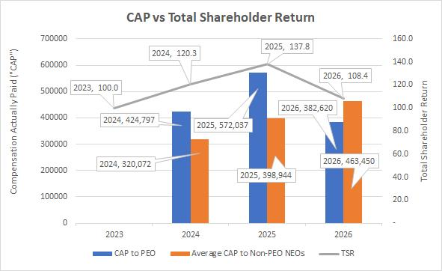
Footer
Header
Footer
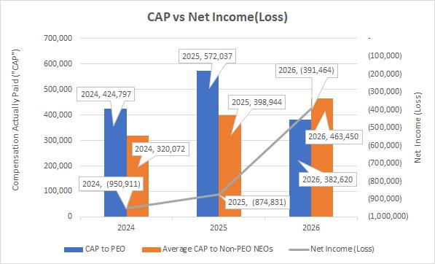.
….
17

EQUITY COMPENSATION PLAN
As discussed above, the Prior Plan expired on July 25, 2022, and as such, no equity awards were granted under such Plan in fiscal year 2026 or 2025. The 2023 Plan was approved at the 2023 Annual Meeting of the Stockholders. During fiscal year 2026, 200,000 awards were granted under the 2023 Plan.
The below table provides information regarding the Prior Plan and the 2023 Plan as of June 30, 2026:
 |  |  |  |  |  |  | Number of
 |  |  |  |  |  |  | securities
 |  | Number of |  |  |  |  | remaining available
 |  | securities |  |  |  |  | for future
 |  | to be issued |  |  | Weighted- |  | issuance under
 |  | upon exercise |  |  | average |  | equity compensation
 |  | of outstanding |  |  | exercise price |  | plans (excluding)
 |  | options, warrants |  |  | of outstanding |  | securities reflected
 |  | and rights |  |  | options, warrants |  | in column (a))
Plan Category |  | (a) |  |  | and rights |  | (b)
Equity compensation plans approved by security holders |  | 269,000 |  | $ | 3.78 |  | 3,161,576
Equity compensation plans not approved by security holders |  | — |  |  | — |  | —
Total |  | — |  | $ | — |  | —
(a)Represents shares issuable upon exercise of (i) 200,000 options issued under the 2023 Plan and (ii) 69,000 options issued under the Prior Plan as of June 30, 2026.
(b)Represents shares available for issuance under the 2023 Plan.
DIRECTOR COMPENSATION

The Company uses cash-based compensation to attract and retain qualified candidates to serve on the Board. In setting director compensation, the Company considers the significant amount of time that directors expend in fulfilling their duties to the Company as well as the skill level required by the Company as members of the Board.

Cash Compensation Paid to Non-employee Board Members

Directors who are not also employees of the Company receive an annual retainer of $20,000, plus $2,500 per director for each Board meeting attended, $3,000 per year for the lead director, $1,500 per director for each committee meeting attended, $6,000 per year for the audit committee chair for service on this committee and $3,000 per year for other committee chairs for service for each remaining committee.

2026 DIRECTOR COMPENSATION TABLE

 |  | Fees
 |  | Earned
 |  | or Paid
 |  | in Cash |  | Total
Name |  | ($) |  | ($)
Thomas L. Doerr |  | 44,500 |  | 44,500
Michael J. Koss (1) |  | — |  | —
William J. Sweasy (2) |  | 43,000 |  | 43,000
Lenore E. Lillie |  | 37,500 |  | 37,500
Michael J. Koss, Jr. (1) |  | — |  | —

Note: The columns which present “Option Awards” and “All Other Compensation” are not presented as there is no information to report in these columns for the fiscal year ended June 30, 2026.
(1)Michael J. Koss and Michael J. Koss, Jr. did not receive additional compensation for their service as members of the Company's Board. Please see “Summary Compensation Table” above for compensation paid to Mr. Koss and Mr. Koss, Jr. for their service as employees.
(2)Mr. Sweasy was granted 10,000 option awards on November 10, 2020, which were fully vested and outstanding as of June 30, 2026.
18

AUDIT COMMITTEE REPORT

THE REPORT OF THE AUDIT COMMITTEE SHALL NOT BE DEEMED INCORPORATED BY REFERENCE BY ANY GENERAL STATEMENT INCORPORATING BY REFERENCE THIS PROXY STATEMENT INTO ANY FILING UNDER THE SECURITIES ACT OF 1933 OR UNDER THE SECURITIES EXCHANGE ACT OF 1934 (TOGETHER, THE “ACTS”), EXCEPT TO THE EXTENT THAT THE COMPANY SPECIFICALLY INCORPORATES THIS INFORMATION BY REFERENCE, AND SHALL NOT OTHERWISE BE DEEMED FILED UNDER SUCH ACTS.

The Audit Committee of the Board of Directors (the “Audit Committee”) is composed of three non-employee directors. The members of the Committee are Mr. Doerr, Ms. Lillie and Mr. Sweasy. Each member of the Audit Committee is “independent” as defined in Nasdaq Listing Rule 5605(a)(2). The Audit Committee held four meetings during the fiscal year ended June 30, 2026.

The responsibilities of the Audit Committee are set forth in its charter, which is reviewed and amended periodically, as appropriate. Generally, the Audit Committee reviews and monitors the Company’s financial reporting process on behalf of the Board of Directors. The Audit Committee operates under a written charter adopted by the Board of Directors. In fulfilling its responsibilities, the Audit Committee, among other things, monitors the integrity of the financial reporting process, systems of internal controls and financial statements and reports of the Company; appoints, compensates, retains and oversees the Company’s independent registered public accounting firm, including reviewing the qualifications, performance and independence of the independent registered public accounting firm; reviews and pre-approves all audit, attest and review services and permitted non-audit services; oversees the audit work performed by the Company’s internal accounting staff; and oversees the Company’s compliance with legal and regulatory requirements. The Audit Committee meets, at a minimum, four times a year with the Company’s independent registered public accounting firm to discuss the results of their procedures, their understanding of the Company’s internal controls and the overall quality of the Company’s financial reporting.
Specifically, the Audit Committee has:

(i) reviewed and discussed the Company’s audited financial statements for the fiscal year ended June 30, 2026, with the Company’s management;

(ii) discussed with WIPFLI LLP (“WIPFLI”), the Company’s independent registered public accounting firm, the matters required to be discussed by the Public Company Accounting Oversight Board (the “PCAOB”) Auditing Standard No. 1301, Communications with Audit Committees;

(iii) received the written disclosures and the letter from WIPFLI as required by the PCAOB regarding the independent registered public accounting firm’s communications with the audit committee concerning independence, and has discussed such matters with representatives of WIPFLI;

(iv) based on the discussions referred to above, recommended to the Board of Directors that the audited financial statements be included in the Company’s Annual Report on Form 10-K for the fiscal year ended June 30, 2026, for filing with the SEC; and

(v) concluded that WIPFLI’s provision of audit and non–audit services to the Company is compatible with their independence.

AUDIT COMMITTEE
Thomas L. Doerr
William J. Sweasy
Lenore E. Lillie
Related Party Transactions

Building Lease. The Company leases its facility in Milwaukee, Wisconsin from Koss Holdings, LLC, which is controlled by five equal ownership interests in trusts held by the five beneficiaries of the former Chairman’s revocable trust and includes current stockholders of the Company. On May 24, 2022, the lease was renewed extending the expiration to June 30, 2028 (the “Extended Term”), with a second extension (“Second Extended Term”) to June 30, 2033. The lease extension maintains the rent at a fixed rate of $380,000 per year for the Extended Term with an increase to $397,000 per year for the Seconded Extended Term. The lease is being accounted for as an operating lease. The Company is responsible for all property maintenance, insurance, taxes and other normal expenses related to ownership.

Stock Repurchases. The Company has previously announced its intention to repurchase shares of Common Stock in the open market or in private transactions as such shares become available from time to time if the Company believes that its stock is undervalued and that such repurchases would enhance the value to stockholders. The Company did not repurchase any shares during the fiscal year ending June 30, 2026.
19

Delinquent Section 16(a) Reports

Section 16(a) of the Securities Exchange Act of 1934, as amended (the “Exchange Act”), requires our directors and executive officers, and persons who own more than 10% of a registered class of our equity securities, to file with the Commission initial reports of beneficial ownership on Form 3 and reports of changes in beneficial ownership of our equity securities on Form 4 or Form 5. The rules promulgated by the Commission under Section 16(a) of the Exchange Act require those persons to furnish us with copies of all reports filed with the Commission pursuant to Section 16(a). Based solely upon a review of such forms filed by the Company on their behalf, in addition to written representations by certain of our directors and executive officers that the required forms were filed, we believe all directors, executive officers and 10% shareholders have filed with the Commission on a timely basis all reports required to be filed under Section 16(a) of the Exchange Act during our fiscal 2026.
‎
20

PROPOSAL 2. ADVISORY VOTE TO APPROVE EXECUTIVE OFFICER COMPENSATION

We are asking our stockholders to provide advisory approval of the compensation of our Named Executive Officers as set forth in this Proxy Statement. This vote is not intended to address any specific item of compensation or any specific Named Executive Officer, but
rather the overall compensation of all of our Named Executive Officers and the philosophy, policies and practices described in this Proxy Statement. We currently hold our Say-on-Pay vote every year.

We have designed our executive compensation program to attract and retain highly qualified, superior leaders, reward performance, and align our executives' interests with the long-term interests of our stockholders. Highlights of our program include the following:

•Pay for Performance. Our incentive program incorporates a pay-for-performance relationship. A portion of our senior executives' compensation is tied to Company and individual performance. The main components of our executive compensation program are base salary and incentive awards, including both cash-based and equity-based awards. We do not provide guaranteed bonuses or stock options.
•Alignment with Stockholder Interests. We promote the alignment of our executives' interests with stockholder interests by focusing on key measures of long-term value creation.
•Responsible Pay Practices. Our executive compensation packages do not provide tax gross ups for our executives. In addition, we have adopted policies covering our executives that require compensation clawbacks in certain circumstances.

We believe that our executive compensation program plays a key role in our long-term success. As required by Section 14A of the Securities and Exchange Act of 1934, we request your vote supporting the following non-binding resolution:

RESOLVED: That the stockholders approve, in a non-binding vote, the compensation of the company’s Named Executive Officers as set forth in this Proxy Statement.

THE BOARD OF DIRECTORS RECOMMENDS THAT

STOCKHOLDERS VOTE “FOR” APPROVAL OF THE ADVISORY RESOLUTION

ON THE COMPENSATION PAID TO OUR NAMED EXECUTIVE OFFICERS.

‎
21

PROPOSAL 3. RATIFICATION OF APPOINTMENT OF INDEPENDENT REGISTERED PUBLIC ACCOUNTING FIRM

The firm of WIPFLI, LLP (“WIPFLI”) has acted as our independent registered public accounting firm to audit the consolidated financial statements of the Company and its subsidiaries for the fiscal year ending June 30, 2026. WIPFLI has served the Company as its independent registered public accounting firm since March 4, 2019. Representatives of WIPFLI are expected to be present at the Meeting, available to respond to appropriate questions and will have the opportunity to make a statement if they desire to do so.

Although this appointment of WIPFLI as the independent registered public accounting firm is not required to be submitted to a vote by stockholders, the Board believes it appropriate, as a matter of policy, to request that the stockholders ratify the appointment. If stockholder ratification (by the affirmative vote of a majority of the shares of Common Stock present in person or represented by proxy at the Meeting and entitled to vote on the subject matter) is not received, the Audit Committee of the Board will reconsider the appointment. Even if the selection of WIPFLI is ratified, the Audit Committee of the Board may, in its discretion, appoint a different firm at any time during the year if the Audit Committee feels that such a change would be in the best interests of the Company and its stockholders. Unless otherwise directed, the proxy will be voted in favor of the ratification of such appointment.

Fees and Services

The following table represents fees for professional services rendered to the Company by WIPFLI for the fiscal years ended June 30, 2026 and 2025, respectively:

 |  | Fiscal Year Ended
 |  | June 30, 2026 |  |  | June 30, 2025
Audit Fees (1) |  | $ | 200,522 |  | $ | 189,217
Audit-Related Fees |  |  | — |  |  | —
Tax Fees |  |  | — |  |  | —
All Other Fees |  |  | — |  |  | —
Total |  | $ | 200,522 |  | $ | 189,217
(1)Audit fees consist of fees incurred for professional services rendered for the audit of consolidated financial statements, for reviews of our interim consolidated financial statements included in our quarterly reports on Forms 10-Q and for services that are normally provided in connection with statutory or regulatory filings or engagements.
Audit Committee Pre-Approval Policies and Procedures

The Audit Committee requires the pre-approval of all audit and permissible non-audit services provided by the Company’s independent registered public accounting firm. Under the policy, the Audit Committee is to specifically pre-approve before the filing of the Form 10-K Annual Report for the previous fiscal year any recurring audit and audit-related services to be provided during the following fiscal year. The Audit Committee also may generally pre-approve, up to a specified maximum amount, any non-recurring audit and audit-related services for the following fiscal year. All pre-approved matters must be detailed as to the particular service or category of services to be provided, whether recurring or non-recurring, and reported to the Audit Committee at its next scheduled meeting. Permissible non-audit services are to be pre-approved on a case-by-case basis. The Audit Committee may delegate its pre-approval authority to any of its members, provided that such member reports all pre-approval decisions to the Audit Committee at its next scheduled meeting. The Company’s independent registered public accounting firm and members of management are required to report periodically to the Audit Committee the extent of all services provided in accordance with the pre-approval policy, including the amount of fees attributable to such services.

In accordance with Section 10A of the Securities Exchange Act of 1934, as amended by Section 202 of the Sarbanes-Oxley Act of 2002, the Company is required to disclose the approval by the Audit Committee of non-audit services performed by the Company’s independent registered public accounting firm. Non-audit services are services other than those provided in connection with an audit or review of the financial statements. During the period covered by this filing, the Audit Committee approved all fees, and the services rendered in connection with these fees, as reported in the table shown above.

THE BOARD OF DIRECTORS RECOMMENDS THAT

STOCKHOLDERS VOTE “FOR” RATIFICATION OF

WIPFLI, LLP AS THE INDEPENDENT REGISTERED PUBLIC ACCOUNTING FIRM

FOR THE FISCAL YEAR ENDING JUNE 30, 2027.
22

Householding of Annual Meeting Materials

SEC rules permit registrants to send a single copy of their proxy materials to any household at which two or more stockholders reside if the registrant believes they are members of the same family. This procedure, referred to as householding, reduces the volume of duplicate information stockholders receive and reduces the expense to the registrant. The Company has not implemented these householding rules with respect to its record holders; however, a number of brokerage firms have instituted householding, which may affect certain beneficial owners of Common Stock. If your family has multiple accounts by which you hold Common Stock, you may have previously received a householding notification from your broker. Please contact your broker directly if you have any questions, require additional copies of the proxy materials, or wish to revoke your decision to household, and thereby receive multiple copies of the proxy materials. Those options are available to you at any time.
TRANSACTION OF OTHER BUSINESS

The Board of Directors of the Company is not aware of any other matters that may come before the meeting. If any other matters are properly presented to the meeting for action, it is the intention of the persons named as proxies in the enclosed form of proxy to vote such proxies in accordance with their discretion on such matters.

‎
23

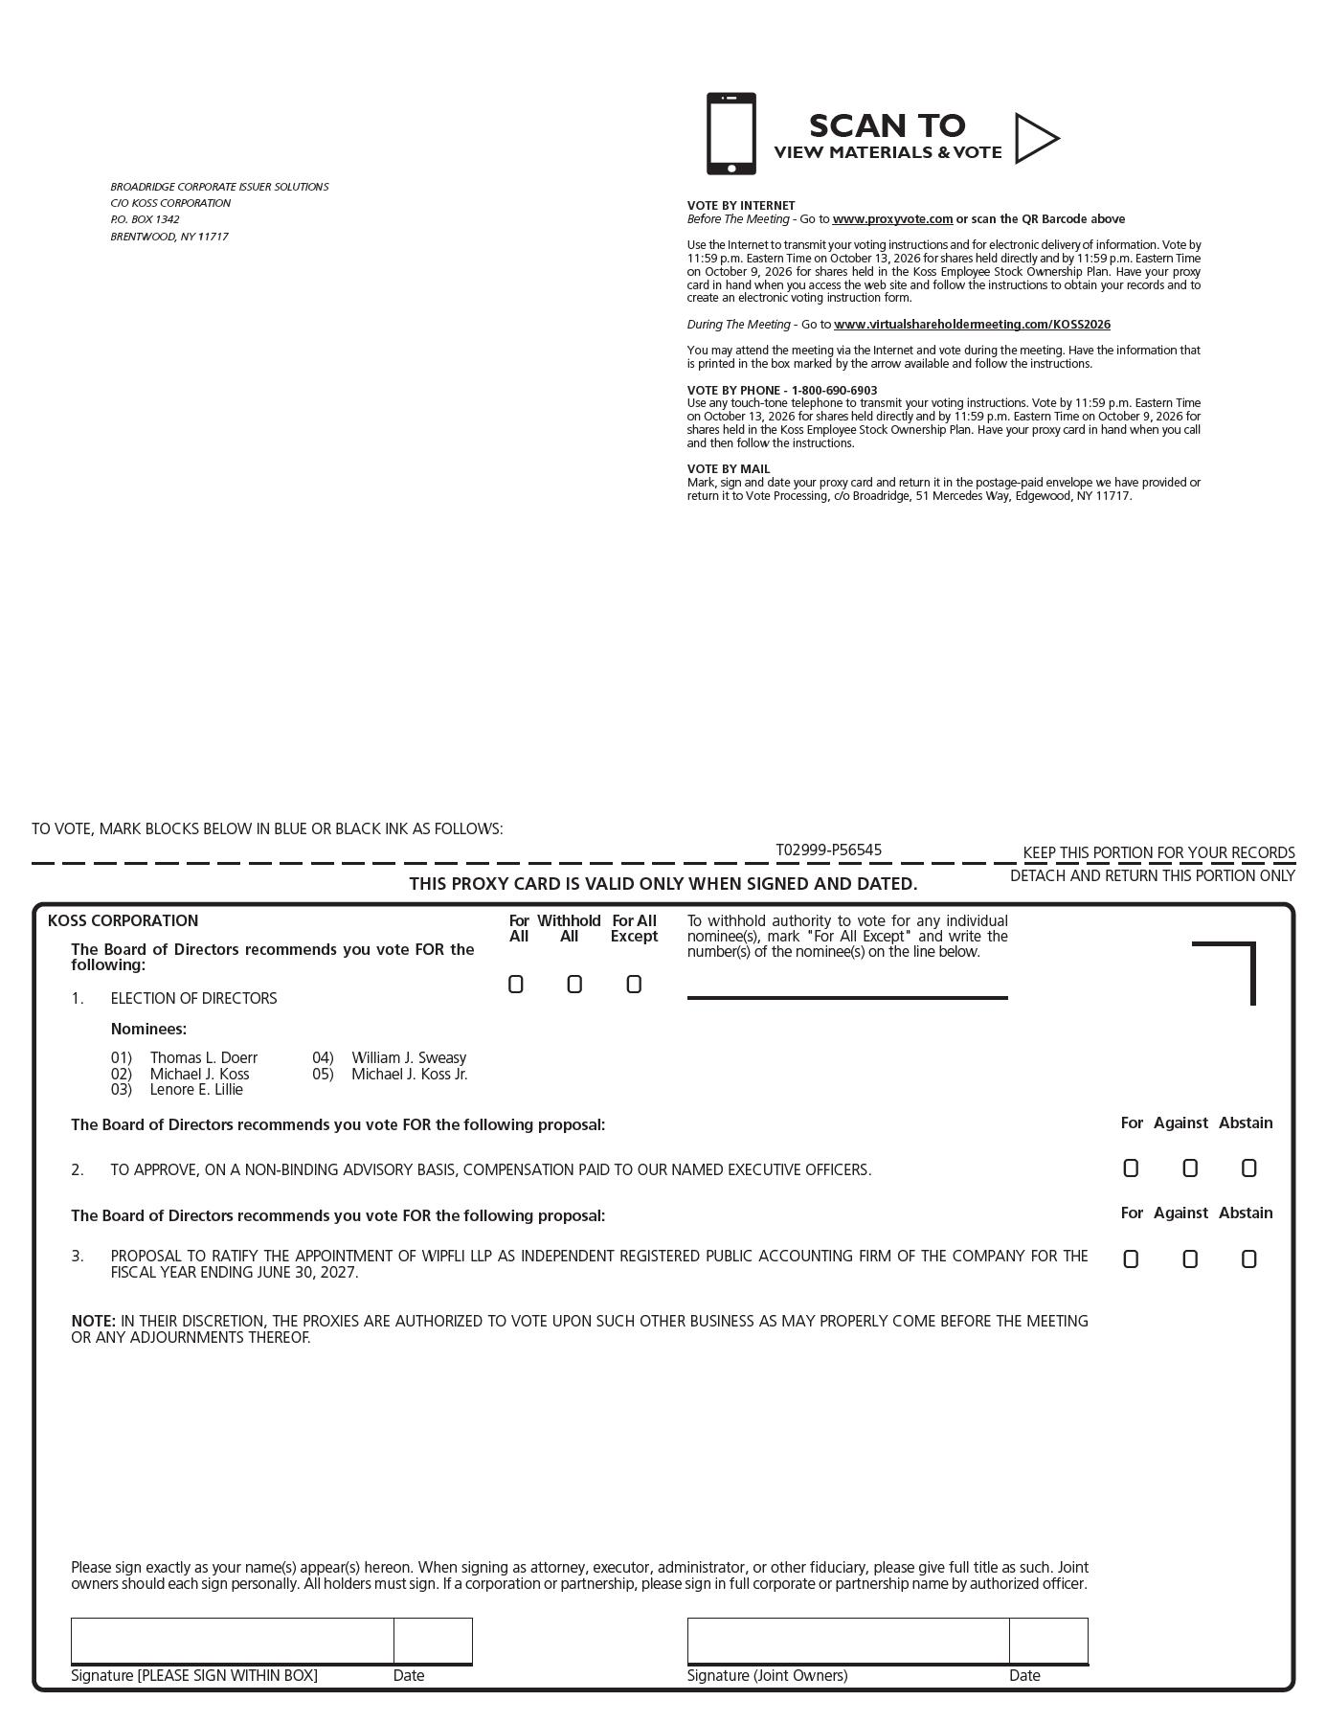
24

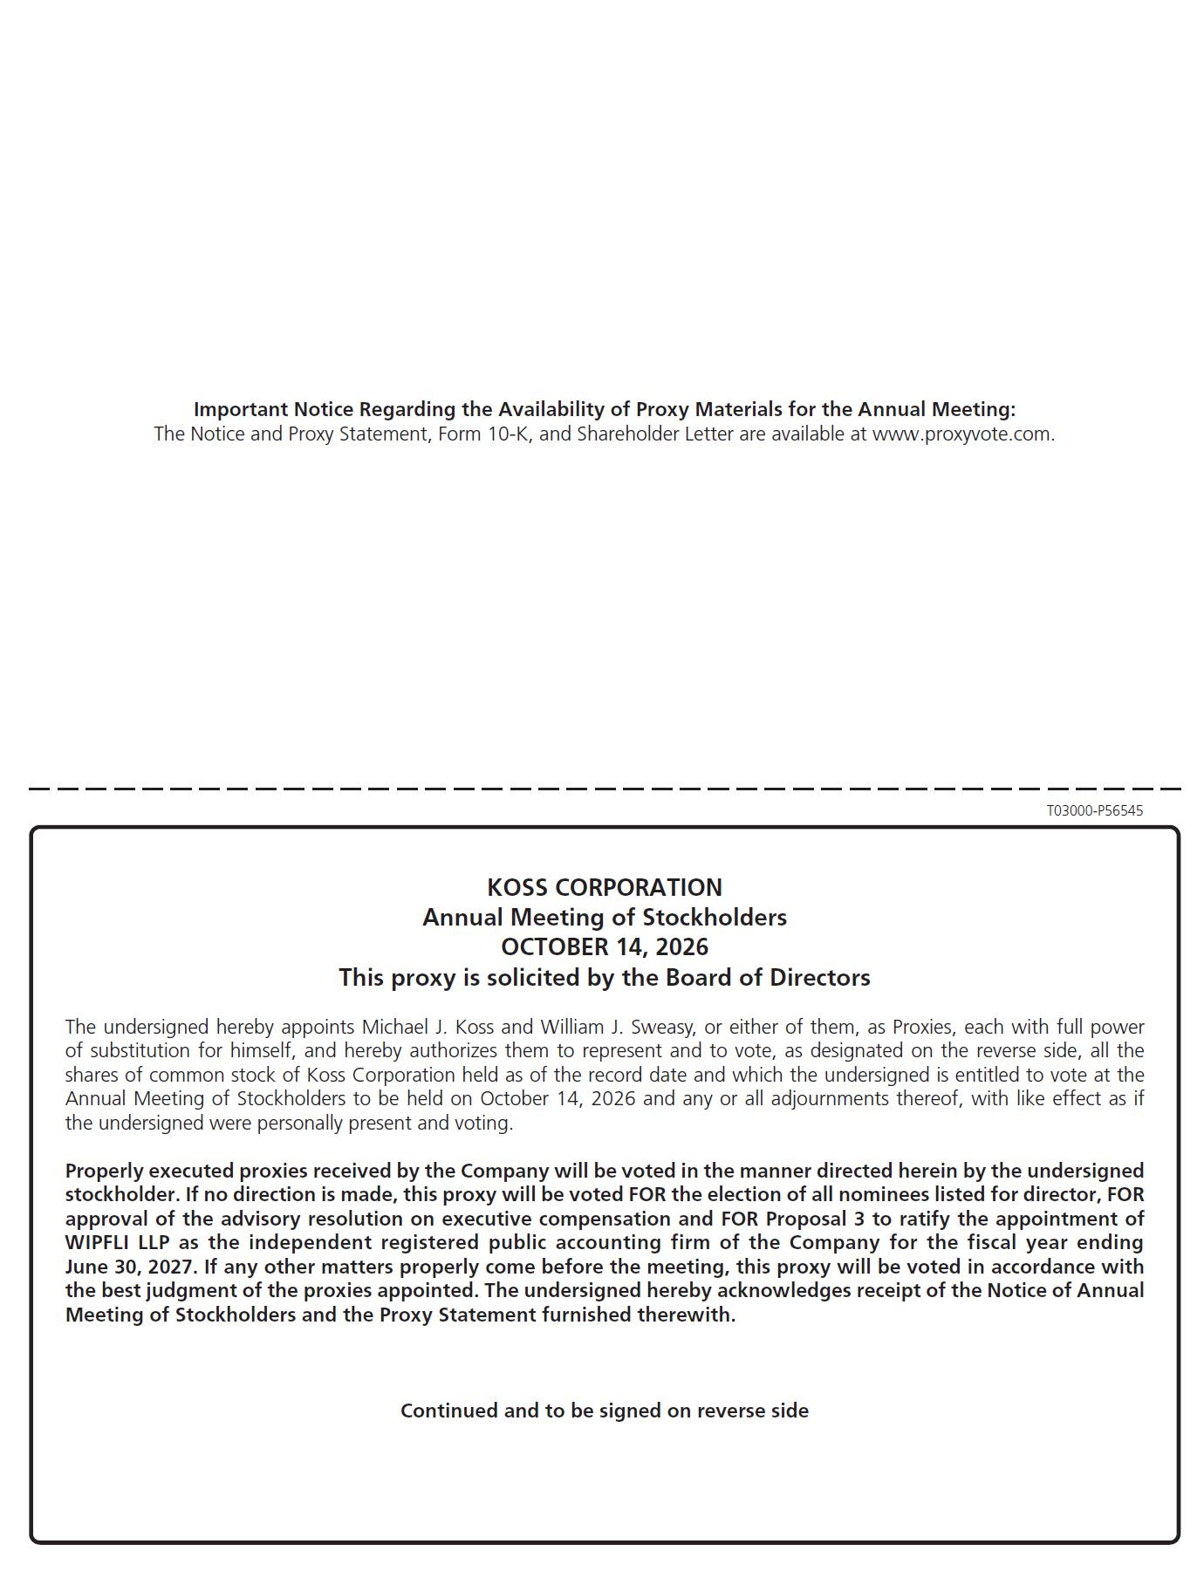
25

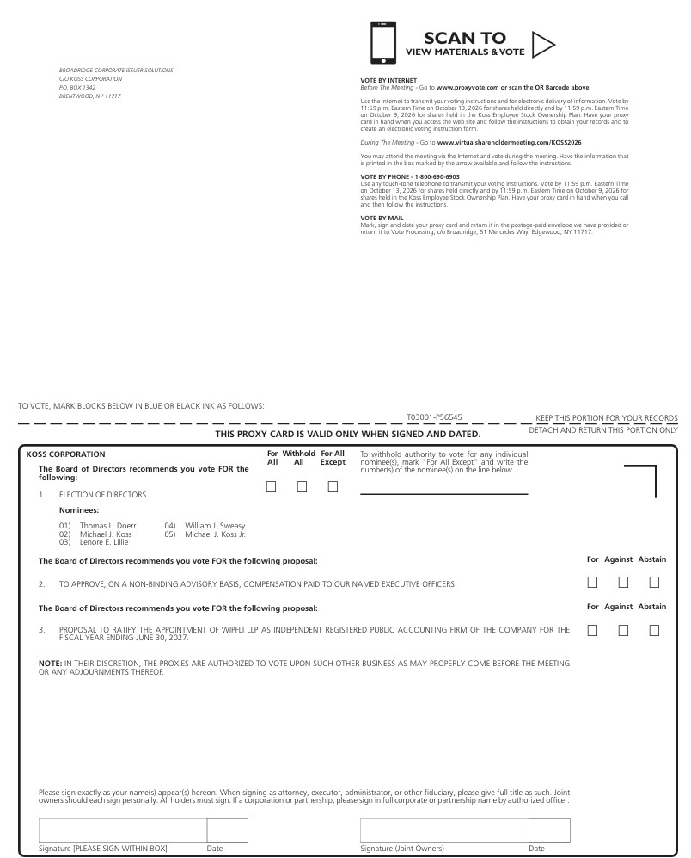
26

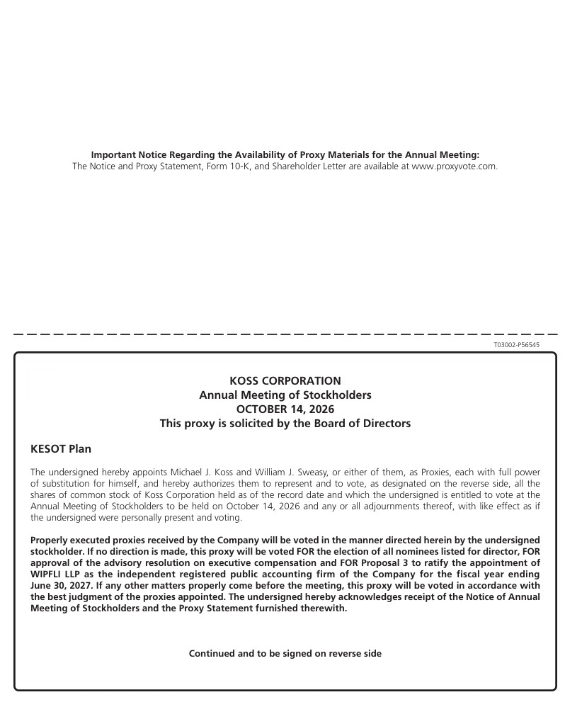
27

